**CONTENT**

|  |  |  |
| --- | --- | --- |
| **CHAPTER** | **CONTENT** | **PAGE NO** |
| **I** | **1.INTRODUCTION** |  |
| **II** | **2. COMPANY PROFILE** |  |
| **III** | **3. PRODUCT PROFILE** |  |
| **IV** | **4. FUNCTIONS OF DEPARTMENT** |  |
|  | **4.1 HUMAN RESOURCE DEPARTMENT** |  |
|  | **4.2 FINANCE DEPARTMENT** |  |
|  | **4.3 MARKETING DEPARTMENT** |  |
| **V** | **5.1 SWOT ANALYSIS** |  |
|  | **5.2 SUGGESTIONS** |  |
|  | **5.3 CONCLUSION** |  |

**CHAPTER - 1**

1. **INTRODUCTION**

The machine industry or machinery industry is a subsector of the industry that produces and maintains machines for consumers, the industry, and most other companies in the economy.

This machine industry traditionally belongs to the heavy industry. Nowadays, many smaller companies in this branch are considered part of the light industry. Most manufacturers in the machinery industry are called machine factories.

**MACHINE MAINTENANCE**

Machine maintenance is the means by which mechanical assets in a facility are kept in working order. Machinery maintenance involves regular servicing of equipment, routine checks, repair work, and replacement of worn or nonfunctional parts. Machines to be maintained include both heavy-duty industrial equipment and simple hand-operated machines.

Maintenance of machinery is frequently handled reactively (e.g. after a breakdown) though it may also be done proactively, as with preventive and predictive maintenance. Preventive maintenance keeps assets in good repair through regularly scheduled service; predictive maintenance relies on equipment monitoring to detect problems before they result in a breakdown.

Automotive parts manufacturing uses many automated machines in order to make steel car parts. For instance, auto body parts manufacturing processes use stamping presses, welding machines, and conveyor systems to convert steel into 3D vehicle doors, chassis, and engine parts.

Each of these machines needs to be perfectly calibrated to perform its function at precisely the right moment in precisely the right way. If one machine doesn’t perform its task correctly, it can easily disrupt the entire manufacturing process. As such, a single system failure will result in costly downtime as the problem is detected and corrected.

Since a brief downtime can result in significant losses due to halted productivity, routine maintenance is regularly performed in order to make sure each asset performs as needed. Preventive maintenance also helps automotive parts manufacturers by resolving potential issues before they result in an expensive-to-fix breakdown.S

**CHAPTER - II**

**2. COMPANY PROFILE**

**SRI RENGA FINANCE**

Sri Renga Finance in Puthur, Trichy is known to satisfactorily cater to the demands of its customer base. It stands located at 21c, Kattu Biulding, Tiruchirappalli, Anda Prm Road, Puthur-620017.The business strives to make for a positive experience through its offerings.

Customer centricity is at the core of Sri Renga Finance in Puthur, Trichy and it is this belief that has led the business to build long-term relationships. Ensuring a positive customer experience, making available goods and/or services that are of top-notch quality is given prime importance.

India’s leading B2B market place, Jd Mart ensures engaging in business activities is a seamless process for small and medium enterprises as well as large businesses. In a wake to enable these businesses to reach their audience, this portal lets them showcase their offerings in terms of the products and/or services through a digital catalogue. This business has a wide range of product offerings and the product/catalogue list includes Truck Wheel Aligner etc.

Contact us:

**Sri Renga Finance**

Retailer of 3 d wheel aligner, trolley jack & axel stands

**Nature of Business** - Retailer

21c, Kattu Biulding,

Tiruchirappalli, Anda Prm Road, Puthur,

Trichy - 620017

**CHAPTER - III**

1. **PRODUCT PROFILE**

* 3D WHEEL ALIGNER
* TROLLY JACK
* AXLE STANDS
* BRAKE MAINTENANCE EQUIPMENTS

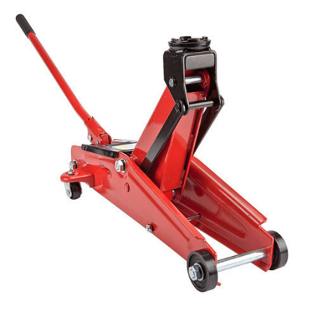

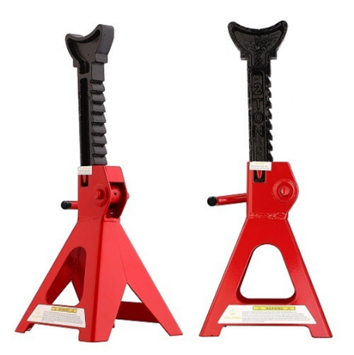

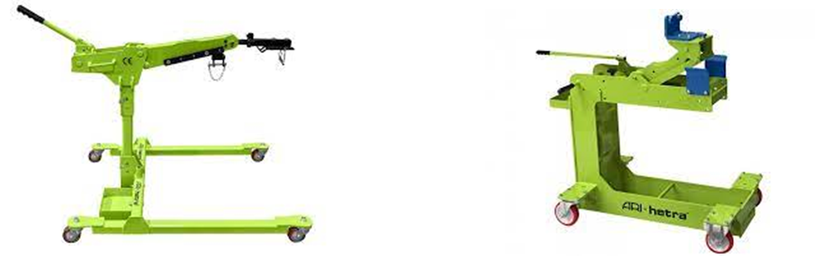

**3D WHEEL ALIGNER**

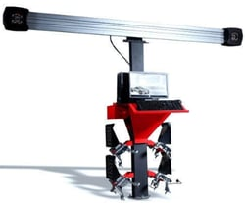

3D wheel alignment allows our mechanics to perform the most precise wheel alignment on all types of cars. This is done by using 2 cameras to perform measurements for each wheel while integrated reference system with camber and inclination pendulums in each sensor head.



3D wheel alignment allows our mechanics to perform the most precise wheel alignment on all types of cars. This is done by using 2 cameras to perform measurements for each wheel while integrated reference system with camber and inclination pendulums in each sensor head. This ensures reproducible results without complicated calibration.

Incorrect alignment can result in rapid and irregular tyre wear and can even affect the handling and safety of the vehicle.

Wheel alignment is generally affected by hitting potholes in the road or by excessive wear to steering or suspension components. Alignment of wheels and tyres to the specification required by your vehicle is an important way to guarantee a smooth ride and to get the most out of your tyres.

The direction and angle at which tyres are set are both important. Wheel alignment involves checking the direction and angle against vehicle manufacturers’ specifications and are both equally important. You may hear these described as toe in, toe out, positive camber or negative camber.

The “Toe” refers to whether the front of the tyres across an axle are closer or further apart than the rear of the tyres. Different types of vehicles need different toe settings to allow for the way that wheels pull either towards each other or apart.

The “Camber” is the inward or outward tilt of a tyre and is specified by the vehicle manufacturer. It can be affected by potholes in the road and needs to be checked regularly to see if any adjustment is required.

Incorrect wheel alignment can result in rapid wearing on the edges of the tyre and could affect the handling on the vehicle and certainly mean a replacement earlier than would otherwise be required. An example reading would be 2-4-4mm or as in the image (below right) 2-1-0mm.

It’s worth keeping an eye out for unusual wear on your tyres, such as premature wear on the inside or outside shoulder, which could be caused by an incorrect camber setting.

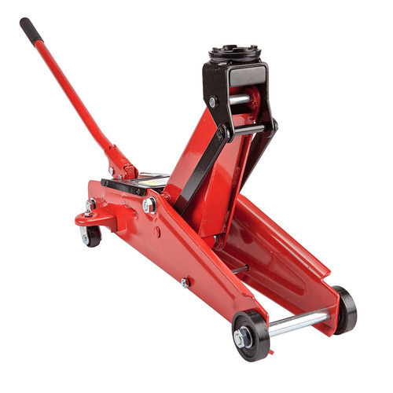**TROLLY JACK**

A trolley jack is a device designed to raise a part of a vehicle via its chassis. A trolley jack usually comes with: wheels for manoeuvring the trolley jack. a handle for positioning the trolley jack under the vehicle and for pumping the hydraulic cylinders. hydraulic cylinders for lifting the vehicle.

Jacks are pieces of material handling equipment that uses force multiplication to lift or move heavy loads. The term jacks can refer to a variety of lifting devices that employ leverage and other methods of mechanical advantage to amplify an applied force to provide the ability to transport a load. Hydraulic jacks are distinguished by their use of an incompressible liquid, such as hydraulic fluid or jack oil, as the means by which force multiplication is achieved. The primary mechanism by which force is applied varies, depending on the specific type of jack, but is typically a screw thread or a hydraulic cylinder. Jacks may be categorized based on the type of mechanism used to generate the lifting force, typically mechanical power, hydraulic power, or pneumatic power.

Mechanical jacks, such as the commonly used car jacks, lift heavy equipment and are rated based on the lifting capacity, which is typically expressed in terms of the number of tons that the jack can handle. Hydraulic jacks tend to have higher lifting capacities than mechanical jacks owing to the amount of force that can be generated by the hydraulic cylinders which produce the lifting action. Common forms of hydraulic jacks include bottle jacks and floor jacks.

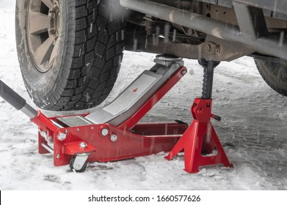

**AXEL STANDS**

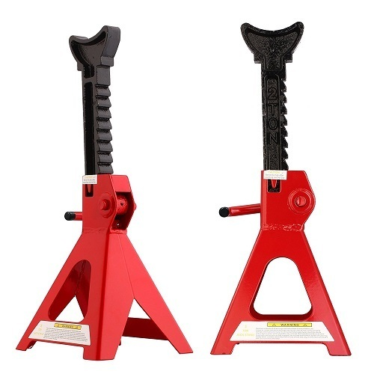Axle stands can be used to support the axle of a vehicle that has been jacked up off the ground, axle stands are often used for more long term support as opposed to a jack that could lose hydraulic pressure over time. The axle stand is a fixed rigid structure that supports the vehicle in the most appropriate place.

Safety is always an important consideration but especially so when fatal accidents are a possibility. Here is how to use axle stands safely and correctly:

1. Make sure your stands are suitable for the vehicle you will be supporting and will be able to support its full weight
2. Place chocks (wheel wedges) beneath the wheels opposite the end of the car you are raising - i.e. beneath the front wheels if you are raising the back of the vehicle, and against the back wheels if you are raising the front
3. 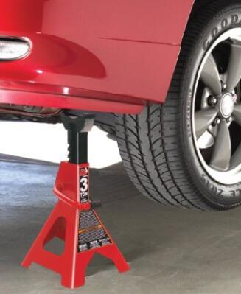Place a bottle jack under one of the two front corners and lift the vehicle to its maximum height, which will be higher than that of your stands
4. Raise the stand to its full height and make sure the locking mechanism is correctly positioned
5. Place the stand in an appropriate location then carefully lower the bottle jack until the vehicle is resting on the stand
6. Engage the locking pins
7. Repeat this process for the second front corner and then place the bottle jack under a central point and lower the rear onto stands
8. Check all four stands, making sure they are steady and have no wobble, adjusting if necessary
9. You can leave the jack in place for additional support if it is not causing any imbalance. Add any other suitably-shaped equipment you may have access to for further additional support, such as wheels, ramps or blocks

**BRAKE MAINTENACE EQUPIMENTS**

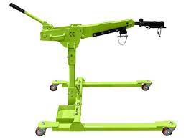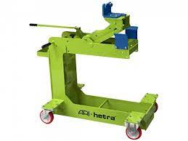Brake service is somewhat of an umbrella term for all things dealing with your brakes. A technician will first perform a brake inspection to make sure all components are working properly. Your service tech will check your brake pads, rotors, clips and calipers to make sure that every component is working as it should.

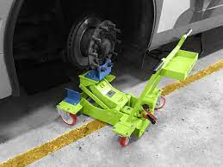

**CHAPTER - IV**

**4. FUNCTIONS OF DEPARTMENT**

* HUMAN RESOURCE DEPARTMENT
* FINANCE DEPARTMENT
* MARKETING DEPARTMENT

**4.1 HUMAN RESOURCE DEPARTMENT**

The human resources department manages the operation of the business. The aim of the department is to finding, selecting, and hiring employees. After the hiring process, the department provides training about the company to the employees. Moreover, the human resource department takes care of the employees in terms of recognition, benefits, and many more.



Human resources play an important role in supporting, developing, and making a friendly culture in the workplace. They take care of recruiting and onboarding candidates, training and development, performance management, payroll, and much more. It brings all the essential values that create a friendly culture in a company. The only aim it carries is to make the organizational process easy and productive.

**1. Recruitment of candidates**

Hiring a candidate is the most basic and very first thing that is followed by HR. Recruitment of candidates is a complex and expensive process, but it brings joy to meet new talents and give a quality check on the skills. It is one of the key HR responsibilities to establish a recruitment procedure. The process comprises identifying the company’s needs and selecting needs based on the criteria. The right candidate can boost the morale of the entire company. If you are handling these responsibilities, you must have a thorough market analysis before you start the process of recruitment.

**2. Hiring the right employees for the right jobs**

I believe that the right employee can do wonders for the company. The job of the human resource department is to look after the recruitment process. It starts with posting advertisements for the job on the job-search platforms. When applications are submitted, the human resources department screens the application and selects suitable candidates. Additionally, improving employer reputation is key to attracting the best candidates.

**3. Processing company payroll**

An individual has to calculate the tax deducted, additions made to the gross salary, and many more. The HR executive has to calculate the appraisals and bonuses added to the gross pay of an employee. The Human Resources team needs to look after the company’s payroll activities to keep the records transparent.

**4. Conduct disciplinary actions**

It is said that if you want to become successful, then you need to be disciplined in the routine. So does, if you want to run a good company with a smooth workflow, then discipline is the very first aspect that needs to be followed by everyone. The human resource manager has to maintain discipline in the company. Sometimes disciplinary actions are necessary on the premises or else the employee does not suit the work. The HR manager may dismiss the employee for the company’s good and welfare.

**5. Designing and updating existing company policies**

The concept of rules and regulation has to be carried if you need productive results in the company. If you are applying for the role of HR, you need to keep updating the existing policies of the company as the primary responsibility of HR. Sometimes the policies don’t work out because of the improper behavior of the employees. If a particular policy is not followed or it is complex, then the HR personnel need to update the policies and rules to make them suitable for company operations.

**4.2 FINANCE DEPARTMENT**

A company's finance department has a fundamental role in making financial decisions for internal and external affairs. Business activities depend on the competence of the finance department, which is organized with specific roles and duties. In this article, we discuss what a finance department is and does, the roles within one and the skills you need to work in a finance department.

A finance department is the unit of a business responsible for obtaining and handling any monies on behalf of the organization. The department controls the income and expenditure in addition to ensuring effective business running with minimum disruptions. Besides the traditional roles of handling the payroll, income and expenses, finance department responsibilities also include economic analysis to improve key business strategies.

**Provide information to management**

The finance department team provides critical information to the company's leadership for effective management. The department provides insights and feasibility reports that inform management's judgments that are pertinent to the company's needs. For example, when launching a new product in the market, the finance department's responsibilities may include supporting its management with financial advice, relaying a funding plan and developing fallback measures.

**Manage equity**

The finance department must efficiently manage the company's equity. A finance department realizes a company's assets investment and optimization through calculated business strategies to maximize profits. The company's management uses finance information to understand and recommend the company improve specific projects and measure the ongoing projects' success rate. The department provides the company with periodic reports that show the awareness of business investment opportunities.

**Cash flow management**

The finance department ensures the adequate and timely provision of funds for the business's operations. It is also the department's role to ensure the company pays its debtors and suppliers on time. The department also coordinates the monitoring of income and expenditures.

**4.3 MARKETING DEPARTMENT**

The Marketing Department plays a vital role in promoting the business and mission of an organization. It serves as the face of your company, coordinating and producing all materials representing the business. It is the Marketing Department's job to reach out to prospects, customers, investors and/or the community, while creating an overarching image that represents your company in a positive light.

Depending on your company, the duties of the Marketing Department may include one or more of the following:

Defining and managing your brand. This involves defining who you are, what you stand for, what you say about yourself, what you do and how your company acts. This, in turn, defines the experience you want your customers and partners to have when they interact with you.

Conducting campaign management for marketing initiatives. Marketing proactively identifies the products and services to focus on over the course of your sales cycle, and then produces materials and communications that get the word out.

Producing marketing and promotional materials. Your marketing department should create the materials that describe and promote your core products and/or services. They should be kept up-to-date as those products and services evolve.

Creating content providing search engine optimization for your website. Your website is often the first (and possibly the only) place people go for information about you. Your marketing department will be responsible for keeping Web content current, while also working to ensure your site comes up quickly when someone searches for your type of business.

Monitoring and managing social media. Marketing should contribute to, manage and maintain your social media pages. It should also manage accounts and carefully watch what’s being posted about you online.

Producing internal communications. Your employees need to understand your company, its values, its goals and its priorities. Marketing is often responsible for employee communications through a newsletter and/or intranet.

Serving as media liaison. When your company is cited in the media, a member of the marketing department often acts as spokesperson for your company, or guides executives in how to respond to media queries.

Conducting customer and market research. Research helps you define target markets and opportunities and helps you understand how your products and services are perceived.

Overseeing outside vendors and agencies. Marketing is typically responsible for selecting and managing the agencies and vendors who produce marketing materials and or/provide marketing support. These may include ad agencies, print vendors, PR agencies or specialists, Web providers, etc.

**CHAPTER - V**

**5.1 SWOT ANALYSIS**

A SWOT analysis is a strategic planning technique that puts your business in perspective using the following perspectives: Strengths, Weaknesses, Opportunities, and Threats. Using a SWOT analysis helps you identify areas your business can improve and maximize opportunities, while simultaneously determining negative factors that might hinder your chances of success.

While it may seems simple on the surface, a SWOT analysis allows you to make unbiased evaluations on:

* Your business or brand
* Market positioning
* A new project or initiative
* A specific campaign or channel

Practically anything that requires strategic planning, internal or external, can have the SWOT framework applied to it, helping you avoid unnecessary errors down the road from lack of insight.

**Importance of SWOT Analysis**

You've noticed by now that SWOT stands for Strengths, Weaknesses, Opportunities, and Threads. The framework seems simple enough that you'd be tempted to forego doing using it at all, relying instead on your intuition to take these things into account.

It gives you the chance to worry and to dream. Adding the SWOT analysis as an important step in your strategic process, you're giving yourself the space to dream, evaluate, and worry before taking action. Your insights in this regard then turn into assets as you create the roadmap for your project or initiative.

It forces you to define your variables. Instead of diving head first into the planning and execution, you're taking inventory of all your assets and roadblocks. These can help you create a more specific and effective roadmap.

It allows you to think more critically and account for mitigating factors. As you identify weaknesses and threats, you're better enabled to account for them in your roadmap, improving your chances for success.

It helps you keep a written account. As your organization grows and changes, you'll be able to strike things off your old SWOTs and add new things as the industry changes. It can be illuminating to look back to where you started as you look ahead at what's to come.

Here, we’ll tackle how to best do a SWOT analysis, provide you with a SWOT analysis template, and conduct SWOT analyses on major brands Apple and Starbucks. When you’re done reading, you’ll have all the inspiration and tactical advice you need to tackle a SWOT analysis for yourself.

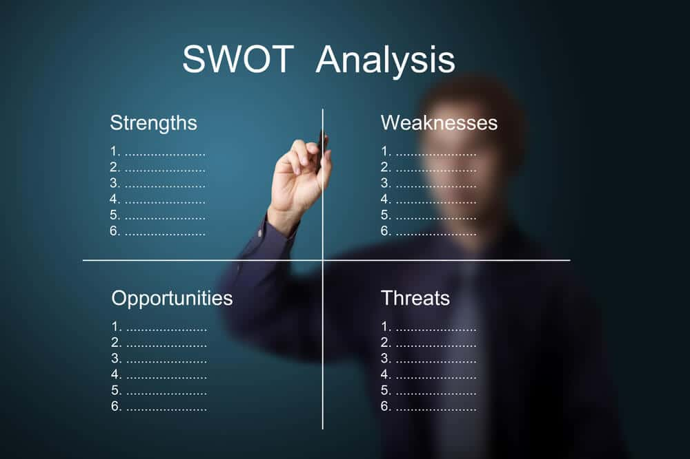

**Strengths**

First off, strengths. While company has many strengths, let’s identify the top three:

1. Brand recognition
2. High prices
3. Innovative products

**Weaknesses**

Next, let’s look at three of weaknesses.

1. High prices
2. Closed ecosystem
3. Lack of experimentation

**Opportunities**

Now, let’s take a look at opportunities

It’s easy to recognize opportunities for improvement, Here’s a list of three we came up with:

1. Expand distribution options
2. Create new product lines
3. Technological advancement

**Threats**

Finally, let’s look at threats

Believe it or not, they do exist.

1. Tough competition
2. Lawsuits
3. International issues

**5.2 SUGGESTIONS**

From the internship the following suggestion can be drawn .In order the dreams comes into reality and for turning liabilities into assets one must meet the needs of the consumers. The factors considered by the consumer before purchasing the equipment are quality, price, design and availability .Income of the customer also decides the purchasing power. So the equipment should concentrate also on low income segments to capture market and position themselves in the minds of the customer with required quality and price.

**5.3 CONCLUSION**

On the whole, this internship was a useful experience. I have gained new knowledge, skills and met many new people. I achieved several of my learning goals, however for some the conditions did not permit. I got insight into professional practice. I learned the different facets of working within company. I experienced that financing, as in many organizations, is an important factor for the progress of projects. Related to my study I learned more about the products. There is still a lot to discover and to improve. The methods used at the moment are still not standardized and a consistent method is in development.

The internship was also good to find out what my strengths and weaknesses are. This helped me to define what skills and knowledge I have to improve in the coming time. It would be better that the knowledge level of the language is sufficient to contribute fully to projects. After my master I think that I could start my working career. However I could perform certain tasks in research better if I practice/know more the research methodologies applied in cetacean studies. It would also be better if I can present and express myself more confidently.